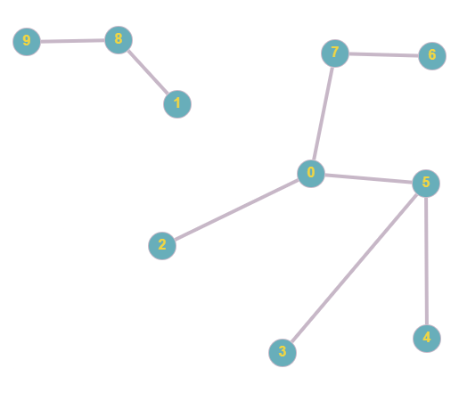

Input file:

10 8

1 8

8 9

0 2

0 5

5 3

5 4

0 7

6 7